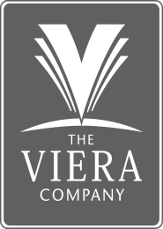

**Christopher Scott Miller, Jr.**

**Executive Vice President of Sales, Marketing and Community Development**

**The Viera Company**

Born in Washington, D.C. and raised in Central Florida, Scott attended the University of Florida and University of Central Florida, where he earned a degree in advertising and marketing.

In 1994, Scott began working for The Viera Company as Community Manager and currently serves as the Executive Vice President of Sales, Marketing and Community Development, where he is responsible for developing and directing Viera’s residential and commercial property sales program and community design and product segmentation. Scott also directs the community management function, and the operation of the Duran Golf Club.

A Florida licensed real estate broker and community association manager, Scott has served The Viera Company as Residential Sales Manager, Director of Sales and Marketing, Vice President of Sales and Marketing, and Vice President of Residential and Community Development. Scott also serves as Vice President/Broker of Viera Commercial Properties, Inc. and Vice Chairman of the Viera Plan Review Committee.

Scott’s professional affiliations include Urban Land Institute where Scott served for 10 years on the National Product Council for Residential Neighborhood Development and currently serves on the ULI Florida Product Council. Scott also serves on the Board of Directors of the Brevard Zoo and is a member of the National Association of Realtors, and Space Coast Association of Realtors and Association of Florida Community Developers. Scott is a graduate of the Leadership Brevard Program.

Scott is married and has three daughters, two son-in-laws, and two grandchildren. He enjoys fishing, hiking, and travel.

9/25