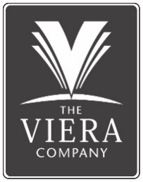

**Mark J. Boyd, Esq.**

Senior Counsel

The Viera Company

Mark Boyd joined The Viera Company in 2023 and currently serves as its Senior Counsel. Mark received his Bachelor of Arts degree from Duke University in 2003 and his Juris Doctor degree from the University of Georgia School of Law in 2008. Prior to joining The Viera Company, Mark was in private practice in Melbourne for a number of years focused on the areas of business, real estate, and estate planning. Earlier in his career, Mark worked as a prosecutor in Georgia and tried many cases successfully to jury verdict during that time.

Mark is a native of Brevard County and has been active in the community as a volunteer, including service on the Board of Directors for organizations including the Melbourne Regional Chamber of Florida's Space Coast (past Chair), Keep Brevard Beautiful (past Chair), Junior Achievement of the Space Coast, and Circles of Care. Mark and his wife, Jessie, have two young sons and enjoy spending time on the water as a family.