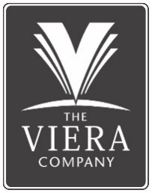

**Karen Esposito**

Director, Sales and Development

Karen joined The Viera Company in 2015. Karen was promoted to Director of Sales and Development, where she manages the residential and commercial sales functions for The Viera Company. She serves as the primary contact for our third-party builders and commercial land sales, and updates market studies and demographic reports. Karen also served as a Board Member on several Developer controlled HOA’s and is a currently member of the Viera Planning Review Committee. Karen belongs to the professional organizations Urban Land Institute and ICSC and holds a Florida Real Estate Broker’s license.

Karen is a graduate of the Florida Institute of Technology with a Bachelor of Science in Business Administration. Karen is proud to call Viera her home since 2003. Karen and her husband, Brian, have a son in high school and a daughter in college.